Readme for Generation 3 Computational Geometry of the ECN Spray G injector

This readme is designed to accompany the Generation 3 Computational geometry produced by Arman Paydarfar, Chinmoy Mohapatra, and David Schmidt at the University of Massachusetts Amherst. Generation 1 refers to the as-designed geometry, free from any defects. Generation 2 is the same as Generation 1, but with the inner diameter of all eight holes (ø2 in the diagram below) uniformly increased to match experimental measurements. Generation 3 is described here.
This geometry is intended to match most of the experimental parameters measured and reported in Strek et al. (2016). However, this Generation 3 geometry better matches the experimental geometry of Strek et al. than the computational geometry used in Strek et al.

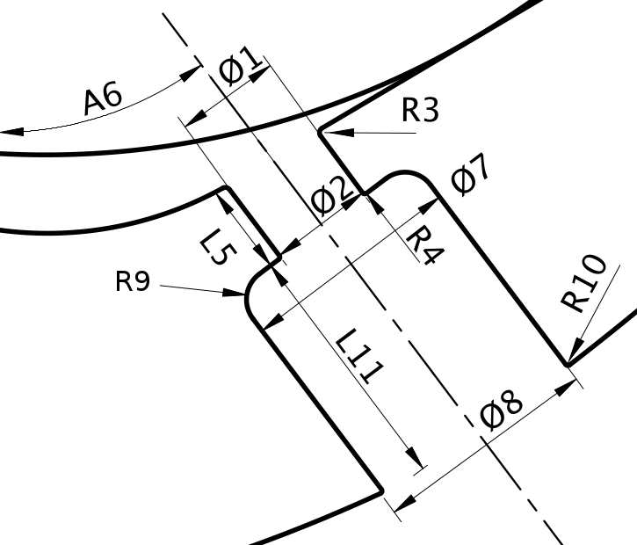
Fig. 1. The nomenclature for the dimensions of the injector geometry, adapted from Strek et al (2016). The counterbore filet, R9, was originally called R8 in Strek et al.

Figure 1 indicates the nomenclature of the injector dimensions that were measured experimentally. The nomenclature has been adapted slightly, for clarity. The counterbore filet is now denoted as feature 9 to distinguish it from feature 8, the counterbore exit diameter.
Most of the nozzle dimensions were modified from the Generation 1 geometry in order to better match the experiments, as shown below in Table 1. For each dimension the experimental value (Exp) is compared to the value found in the Generation 3 geometry (CFD).
Features | Hole1 |  | Hole2 |  | Hole3 |  | Hole4 |  | Hole5 |  | Hole6 |  | Hole7 |  | Hole8 |  | Ideal
 | Exp | CFD | Exp | CFD | Exp | CFD | Exp | CFD | Exp | CFD | Exp | CFD | Exp | CFD | Exp | CFD
Φ1(μm) | 177 | 177 | 172 | 172 | 168 | 168 | 172 | 172 | 172 | 172 | 172 | 172 | 166 | 166 | 170 | 170 | 165
Φ2(μm) | 177 | 177 | 172 | 172 | 172 | 172 | 175 | 175 | 175 | 175 | 172 | 172 | 170 | 170 | 172 | 172 | 165
R3(µm) | 17 | 17 | 19 | 19 | 10 | 10 | 15 | 15 | 19 | 19 | 7 | 7 | 6 | 6 | 7 | 7 | 0
R4(µm) | 11 | 11 | 6 | 6 | 17 | 17 | 11 | 11 | 7 | 7 | 6 | 6 | 7 | 7 | 11 | 11 | 0
L5(µm) | 159 | 159 | 161 | 161 | 168 | 168 | 172 | 172 | 159 | 159 | 162 | 162 | 162 | 162 | 162 | 162 | 170
A6(º) | 36 | 37 | 36 | 37 | 37 | 37 | 37 | 37 | 37 | 37 | 37 | 37 | 36 | 37 | 37 | 37 | 37
Φ7(μm) | 384 | 388 | 386 | 388 | 382 | 388 | 382 | 388 | 382 | 388 | 384 | 388 | 386 | 388 | 386 | 388 | 388
Φ8(μm) | 389 | 388 | 386 | 388 | 387 | 388 | 387 | 388 | 386 | 388 | 387 | 388 | 387 | 388 | 389 | 388 | 388
R9(µm) | 57 | 57 | 55 | 55 | 55 | 55 | 55 | 55 | 49 | 49 | 65 | 65 | 66 | 66 | 63 | 63 | 40
R10(µm) | 9 | 9 | 7 | 7 | 7 | 7 | 7 | 7 | 12 | 12 | 6 | 6 | 13 | 13 | 17 | 17 | 0
L11(µm) | 423 | 474 | 434 | 461 | 441 | 465 | 441 | 472 | 435 | 490 | 426 | 494 | 458 | 494 | 430 | 494 | 470
Table 1. Experimental and computational dimensions of the injector geometry.
In the Generation 3 geometry file, most dimensions have been edited to match the experimental values given in the table above. All the features that were available to be modified were modified. Specifically, ø 1, ø 2, R3, R4, L5, R9 and R10 all match experimental values currently. The dimensions A6, ø 7, ø 8, and L11 were left unmodified because the file did not include any options to easily alter these parameters. L11 may be inaccurate because it was difficult to verify the length, since the definition was somewhat ambiguous. The plenum was extended, and now has a 9mm diameter.

References:
Strek, P., Duke, D., Swantek, A., Kastengren, A., Powell, C. F., & Schmidt, D. P. (2016). X-ray radiography and CFD studies of the Spray G injector (No. 2016-01-0858). SAE Technical Paper.

