**ECN10**

*SUSTAINABLE FUEL SPARK IGNITION*

*SUBMISSION GUIDELINES*

Experiments: Characteristics of Spray M

(large-scale and near-nozzle flow)

Joonsik Hwang (KAIST)

jhwang@kaist.ac.kr

Simulations: Internal flow, free spray, and wall impingement of Spray M

Francesco Duronio (Università degli Studi dell'Aquila)

francesco.duronio@univaq.it

# Introduction

We are motivated to understand the fuel-air mixing process using synthetic fuel (methanol) and synthetic-blend gasoline E10 surrogate (PACE-20) with Spray M injector under both cold start and late-injection conditions in gasoline direct-injection (GDI) engines. The motivation is to understand spray-wall interaction during cold start conditions with variation of fuel and ambient temperature. Under the operating conditions, spray evolution is characterized by the following:

* Use of synthetic (methanol) and synthetic-blend gasoline E10 surrogate fuels
* Injection pressure below 350 bar
* Ambient density and temperature typical of gasoline engines, ranging from intake (possibly sub-atmospheric) throughout the compression stroke
* Multi-hole injector geometry interactions

Over the years, ECN efforts in this topic were dedicated to: the definition of the injector (ECN1 and ECN2), initial experiments and modeling of the “reference” condition (ECN3), detailed characterization of the spray morphology (ECN4), careful internal geometry characterization, air entrainment, and plume interaction effects (ECN5), investigation of spray behavior under different operating conditions (ECN6), Sprays and conditions where flash boiling and wall wetting occurred (ECN7), Characteristics of GDI sprays from inner-nozzle flow to large-scale evolution and understanding sprays’ behaviors from a constant-volume chamber to real engine applications (ECN8), Characterization of new Spray M injector using Methanol and PACE-20 fuels. Please refer to past proceedings (<https://ecn.sandia.gov/ecn-workshop/search-presentations/>) to understand the findings and context for the current work.

# Objectives

## Target Fuels

Listed in priority order:

1. 100% methanol
2. PACE-20 Fuel*
3. E00 Fuel*
4. 100% iso-octane

Built upon all the previous workshops above, ECN10 will specifically focus on the targeted conditions for Spray M with methanol and PACE-20 fuels. The main objectives will be to:

* Understand mixing under boiling conditions (boiling transition and flash boiling)
* Explore the impact of multi-component fuels and methanol (particularly at vaporizing conditions)
* Examine spray-wall interaction using different fuels (particularly at cold start conditions)
* Understand fuel and ambient temperature effects on the mixing process
* Expand the generality of modeling to a broader range of ambient conditions

To this end, nine conditions, encompassing free spray and wall impingement cases, will be considered at the workshop, as given in the table below. All conditions will be non-reacting (100% N2, 0% O2). Rate of injection shapes, are available for each of these conditions, including multiple-injection conditions in sfsiECN10.zip.

*PACE-20 Fuel composition:

|  |  |  |  |
| --- | --- | --- | --- |
| Component | liq. vol. frac. | mol. Frac. | mass. frac. |
| ethanol | 0.0955 | 0.1891 | 0.1016 |
| n-pentane | 0.1395 | 0.1390 | 0.1168 |
| 1-hexene | 0.0541 | 0.0500 | 0.0491 |
| toluene | 0.0919 | 0.1004 | 0.1079 |
| n-heptane | 0.1153 | 0.0911 | 0.1063 |
| iso-octane | 0.2505 | 0.1759 | 0.2341 |
| 1,2,4-trimethylbenzene | 0.1187 | 0.0996 | 0.1396 |
| cyclopentane | 0.1050 | 0.1299 | 0.1062 |
| tetralin | 0.0295 | 0.0249 | 0.0384 |

Free Spray

Naming convention

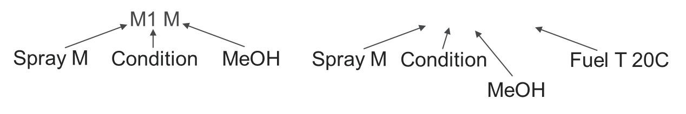

|  |  |  |  |  |  |  |  |
| --- | --- | --- | --- | --- | --- | --- | --- |
| Name | Tfuel [K] | Ta [K] | ρa [kg/m3] | Pa [kPa] | Pinj [MPa] | Hydraulic Injection Duration [ms] | Total Fuel (mg) |
| M1 M | 363 | 573 | 3.5 | 600 | 20 | 0.74 | 9.75 |
| M1 P20 | 363 | 573 | 3.5 | 600 | 20 | 0.74 | 9.7 |
| G1 P20 | 363 | 573 | 3.5 | 600 | 20 | 0.74 | 9.4 |
| M2 M | 363 | 333 | 0.5 | 50 | 20 | 0.74 | 9.9 |
| M2 P20 | 363 | 333 | 0.5 | 50 | 20 | 0.74 | 9.7 |
| G2 P20 | 363 | 333 | 0.5 | 50 | 20 | 0.74 | 9.4 |
| M2 M F20C | 293 | 293 | 0.5 | 50 | 20 | 0.74 | 9.9 |
| M2 M F60C | 333 | 333 | 0.5 | 50 | 20 | 0.74 | 9.9 |
| M2 M F90C | 363 | 363 | 0.5 | 50 | 20 | 0.74 | 9.9 |

Wall impingement cases

Naming convention

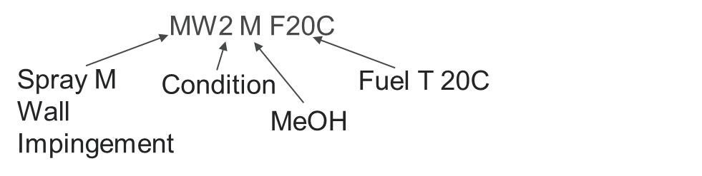

|  |  |  |  |  |  |  |  |
| --- | --- | --- | --- | --- | --- | --- | --- |
| Name | Tfuel [K] | Ta [K] | ρa [kg/m3] | Pa [kPa] | Pinj [MPa] | Hydraulic Injection Duration [ms] | Total Fuel (mg) |
| M1 M | 363 | 573 | 3.5 | 600 | 20 | 0.74 | 9.75 |
| M1 P20 | 363 | 573 | 3.5 | 600 | 20 | 0.74 | 9.7 |
| G1 P20 | 363 | 573 | 3.5 | 600 | 20 | 0.74 | 9.4 |
| M2 M | 363 | 333 | 0.5 | 50 | 20 | 0.74 | 9.9 |
| M2 P20 | 363 | 333 | 0.5 | 50 | 20 | 0.74 | 9.7 |
| G2 P20 | 363 | 333 | 0.5 | 50 | 20 | 0.74 | 9.4 |
| M2 M F20C | 293 | 293 | 0.5 | 50 | 20 | 0.74 | 9.9 |
| M2 M F60C | 333 | 333 | 0.5 | 50 | 20 | 0.74 | 9.9 |
| M2 M F90C | 363 | 363 | 0.5 | 50 | 20 | 0.74 | 9.9 |

## Experimental objectives

Experimental techniques that provide both global behavior and detailed in-situ quantification are encouraged. ECN10 will focus on:

* Detailed data release, analysis, and comparison of the flash-boiling G2 condition
* Evaluation of the self-consistency of mixing, velocity, and penetration data as a whole to identify the most effective experimental techniques
* Evaluation and (re-evaluation) of vapor and liquid envelopes, concentration, and plume direction using new liquid-extinction experiments and analysis
* Development of quantitative diagnostics in mixed (liquid and vapor) regions of the spray
* Further standardization of experimental techniques and derived metrics
* Archival release of well-documented datasets to the ECN website

## Modeling objectives

Simulations aim to advance the physical description of the internal flow, in-nozzle cavitation and flash boiling phenomena, as well as external spray flow, mixing, and evaporation. In particular:

* Internal flow and near-field mixing that leads to predictive plume dispersion (rather than tuned spray angles), correct representation of vaporization phenomena.
* Spray collapse and plume-interaction under high ambient temperature or low ambient pressure (flash boiling) conditions
* Spray-wall interactions with the variation of wall, fuel, and ambient temperatures.
* How spray fuel properties affect evaporation, spray breakup, and coalescence
* Coupling between expensive simulations (VOF, LES) and less expensive simulations (Lagrangian spray) to establish reliable inputs.

Spray modeling approaches with different resolutions, computational costs, and methodologies (Eulerian-Lagrangian, Eulerian-Eulerian) using both RANS and LES are encouraged to bridge the gap between high-fidelity and engineering-level simulations.

# Deadline for submissions

October 30, 2025

# Nomenclature and boundary condition definitions

## Geometry

Simulation and experimental submissions will follow the ECN coordinate system convention for Spray G (the same as Spray M), as described in <https://ecn.sandia.gov/gasoline-spray-combustion/target-condition/spray-g-plume-orientation/>. The injector nozzle with the holes numbered and the coordinate system axis is shown. The SAE J2715 standard orientation convention has been used by the ECN Spray G community, with z = 0, y = 0, and x = 0 defined **as the tip of the nozzle, NOT the flat of the injector** (see Fig. 2).

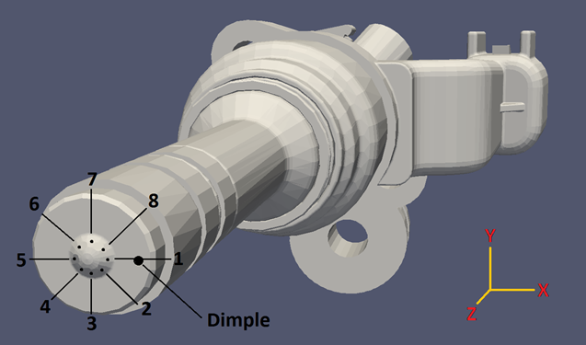

*Fig. 1. Hole numbering and coordinate system convention of Spray G*

Note that the tip protrudes past the hole exit, meaning the plumes begin at negative z values. Conventions for describing the drill angle and derived plume geometry are given below. Another coordinate system, z´, colinear with the hole drill angle and beginning at the exit of the inner hole (z´ = 0), is introduced for use with internal flow simulations and experiments.

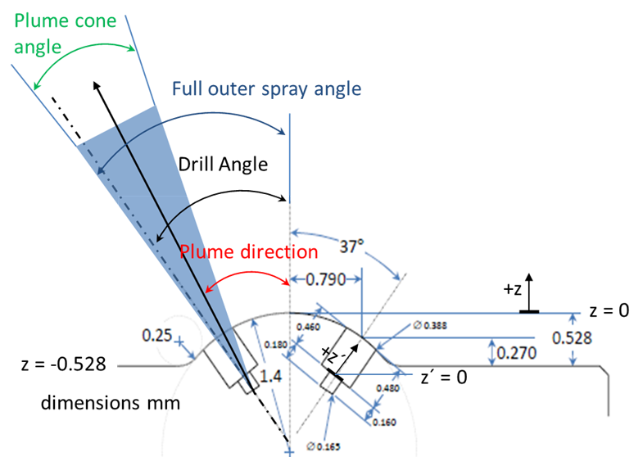

*Fig. 2. Specified Spray G dimensions and nomenclature*

To specify the geometry difference between two injectors (Spray M and Spray G), Fig. 3 and 4 show the recommended simulation settings, such as injector diameters, plume directions, and plume cone angles.

|  |  |
| --- | --- |
|  |  |
| 1. Spray G injector | 1. Spray M injector |

*Fig. 3. Specified Spray G and Spray M dimensions and coordinates*

Detailed 3D geometry surface, CAD, and mesh files of Spray G are available at <https://ecn.sandia.gov/gasoline-spray-combustion/computational-method/mesh-and-geometry/>. However, there is no 3-D data available for Spray M. Details can be found at the ECN 8.11 with the following link: <https://ecn.sandia.gov/workshop/ECN9/ECN8.11.mp4>

|  |  |
| --- | --- |
|  |  |
| 1. Measured plume direction | 1. Measured plume cone angle |

*Fig. 4. Comparison of plume direction and plume cone angle*

## Rate of injection

The measured rate of injection for use in simulations is given at <https://ecn.sandia.gov/gasoline-spray-combustion/target-condition/primary-spray-g-datasets/>. PLEASE NOTE THIS IS A NEW RATE OF INJECTION, updated after ECN5. RERUN OLD SIMULATIONS USING THIS NEW RATE OF INJECTION.

**The injection rate profiles below should be rescaled in time and ROI to meet hydraulic injection duration and injection quantity listed in Table of Free Spray**

The rate of injection of Spray M under G1 and G2 conditions are :

|  |  |
| --- | --- |
|  |  |
| 1. G1 condition | 1. G2 condition |

## Needle movement

X-ray phase contrast measurements of needle lift and wobble are provided for Injector #28 at conditions close to G1, G2, and G3, with unheated ambient conditions. These data are available at <https://anl.box.com/v/XRaySpray>

## Temperature

Fuel temperature, nozzle temperature, and gas temperature are as specified at the start of injection.

## Initial dissolved non-condensable gas content

Simulations will be performed with no non-condensable gas addition.

# Submission of experimental and modeling results

Using the defined coordinate system, all experiments and simulations will provide data relative to the start of injection. The start of injection is defined as the time of emergence of the first liquid out of the counterbore section of the hole. Following the description below, all participants in the simulation session will be given a set of Python scripts to generate the required projected liquid volume (PLV), liquid volume fraction (LVF), and schlieren images.

Submissions will include several processed indicators of spray penetration (liquid and vapor) and growth as a function of time, as well as detailed 2D cut plane or projection data at specific locations and timings.

## Data format

Raw numeric data is required. Simple time-resolved may be returned in delimited format. ParaView compatible eg:.vtk file, MATLAB .mat file (preferred).

## Global and Time-Resolved Spray Indicators

These are quantities describing the overall spray behavior, resolved in time.

## Vapor penetration:

## *Experimental*

Schlieren or other diagnostics sensitive to fuel vapor are utilized in either the primary or secondary orientation. Penetration is defined as the maximum axial penetration of ANY plume, as described in <https://ecn.sandia.gov/gasoline-spray-combustion/experimental-diagnostics/gasoline-jet-penetration/> .

## *Modeling*

Defined as the farthest axial distance where mixture fraction is less than 0.001.

## Liquid-phase penetration:

To assess the vaporization characteristics of the spray, we define a threshold for axial (or radial) liquid penetration. Past work has shown inconsistency when using a Mie-scatter diagnostic and other difficulties if using a liquid-volume fraction criteria, as explained by the ECN5.9 slides and recording given by Pickett, accessible at <https://ecn.sandia.gov/gasoline-spray-combustion/experimental-diagnostics/liquid-penetration-length/> . The parameter for comparison will be the “projected liquid-volume” defined as

$\int_{-y_{∞}}^{y_{∞}}{LVF∙dy }$ (1)

where *LVF* is the local liquid volume fraction (i.e. units of mm3 liquid / mm2) and *y* is the cross-stream direction (*x* could be exchanged for *y* for Spray G if appropriate for the experiment).

## *Experimental method to derive projected liquid volume*

Laser extinction or diffused back-illumination extinction imaging (DBIEI) with sufficient radiance and collection angles to eliminate beam-steering are required to perform these experiments, as detailed in the above links and presentations. Past datasets which show beam-steering may be analyzed and offset to account for beam-steering while documenting all assumptions. Note that G2 and G3 conditions may exhibit minor beam-steering artifacts because of the lower ambient density and cooler ambient temperature, making it possible to analyze the data quantitatively. Extinction measurement provides the optical thickness ** of liquid objects along the beam path, where the transmitted intensity *I* normalized by the baseline light intensity *I0* is related to ** by

$I/{I_{0}}= e^{-τ}$ (2)

and the optical thickness is related to extinction along the path due to liquid with

$τ= \int_{-y_{∞}}^{y_{∞}}{C_{ext }^{*}}\frac{LVF}{π{d^{3}}/6}dy$ (3)

where *d* is droplet diameter and $C_{ext }^{*}$ is the extinction cross-section from Mie-theory, depending upon droplet size, wavelength, and collection angle (the * superscript designates collection with a finite collection angle, rather than complete extinction). If one assumes a monodisperse droplet size distribution, Equation 3 becomes

$τ\frac{π{d^{3}}/6}{C_{ext }^{*}}= \int_{-y_{∞}}^{y_{∞}}{LVF}∙dy$, (3)

Allowing the measured optical thickness and estimates for droplet optical properties. For the sake of consistency, we will assume a droplet size of 10 m, based upon SMD measurements performed by Scott Parrish (GM) within the plume (see <https://ecn.sandia.gov/gasoline-spray-combustion/target-condition/primary-spray-g-datasets/>) to calculate $C_{ext }^{*}$ for a given experiment. The left-hand side of Equation 3 may therefore be evaluated (for this example) to estimate the projected liquid volume.

## *Liquid-extinction length*

Because of the need to explore sensitivities in models and experiments, two different thresholds are required:

.

$$\int_{-y_{∞}}^{y_{∞}}{LVF∙dy=0.2∙{10}^{-3} \frac{mm^{3} liquid}{{mm}^{2}} AND 2.0∙{10}^{-3} \frac{mm^{3} liquid}{{mm}^{2}}}$$

The maximum axial position (of any plume) with liquid-volume projection less than these “low” and “high” thresholds will be referred to as “liquid-extinction” length.

## *Liquid-extinction width*

At an axial position of z = 15 mm and z = 25 mm, the radial width at these two thresholds is defined as the “liquid-extinction” width.

Both the liquid-extinction width and liquid-extinction length will be returned with respect to time. In the next section, 2D datasets for projected liquid volume (PLV) will also be requested for further analysis at particular time steps.

## *Spatial- (and time-) resolved variables*

Requested 2-D binary generated by the given Python scripts are to be provided on different cut planes (Fig. 4). Provide data from 0.1 – 2 ms (or max) in 0.1 ms time-steps.

* Axial (x-y) cut planes: z = 10, 15, 30 mm
* Axial cut plane normal to the drill angle (z’, Fig. 2): z´ = -0.1, 0, 0.1, 1.0 mm
* The central x-z cut plane (z = -2 to 40 mm) in primary position
* The “secondary” x’-z cut plane (z = -2 to 40 mm, rotated about z by 22.5 degrees)

## Description of the simulation

Please describe the methodology adopted by filling in the following table:

|  |  |  |
| --- | --- | --- |
| **Methodology** | Eulerian-Eulerian (internal flow simulations)/Eulerian-Lagrangian (far field) |  |
| **Software** | CONVERGE, OpenFOAM, etc .. |  |
| **Condition investigated** | M1, M2, … |  |
| **Domain dimensions** | LxWxH |  |
| **Meshing strategy** | Static mesh, Fixed refinement regions, Adaptive mesh refinement, overset grids, … |  |
| **Fluids properties** | An explanation of how fluid properties were calculated or tabulated. This may be a reference to a database or equation of state. Please specify for any phase/species involved in the simulation. |  |
| **Turbulence model** | What turbulence closure is used? |  |
| **Relevant initial conditions** | What is the initial gas and liquid velocity and turbulence distribution at the time of injection? |  |
| **Relevant boundary conditions** | Provide a table of boundary conditions that were used for each equation. |  |
| **Mesh sensitivity study** | Please comment on the grid sizing chosen. |  |
| **INTERNAL FLOW SIMULATIONS** | | |
| **Phase transition model** | HRM, HEM, … |  |
| **Interface treatment** | What interface treatment was used? For example, it is insufficient to say “VOF” but rather explain whether a geometric interface construction was used or some interfacial compression scheme was employed with flux limiting. If a diffuse interface treatment was used, provide a reference describing the governing equations. |  |
| **Coupling** | Does the internal simulation couple to a Lagrangian spray simulation? If so, how? |  |
| **Additional models** | Were any special phenomena considered? Examples are compressibility and dissolved gas nucleation. |  |
| **Needle lift** | What needle lift was used, fixed or variable? If a fixed needle lift was used, what was the value? |  |
| **LAGRANGIAN SPRAY SIMULATIONS** | | |
| **Injection model** | Did you specify ROI, or another variable such as needle position or injection pressure? Parcel distribution, |  |
| **Injection parameter** | Parcel count, mass injected, plume direction, plume angle, initial droplet size, and temperature |  |
| **Breakup modeling** | Relevant information regarding the breakup model/s adopted, and eventual references where interested readers can learn more about the details. |  |
| **Vaporization modeling** | Relevant information regarding the phase-change model, and eventual references where interested readers can learn more about the details. |  |
| **Other Lagrangian models** | Drop drag, turbulent diffusion… |  |

## Specific requests for internal and near-nozzle, evaporating spray

## *Internal flow simulations*

Note that time 0 is defined as the time of the first passage of liquid out of the hole of the counterbore. Internal simulations submissions should include the following results:

1. Predicted mass rate of injection in g/s versus time in ms. This should be submitted as a plain text ASCII file with time as the first column and ROI as the second.
2. Provide the liquid fuel ROI, fuel-vapor ROI, and non-condensable gas ROI similar to the total fuel ROI in item #1.
3. Density maps at 1 and 2 mm from the injector tip.

## *Lagrangian spray simulations*

Provide information about:

1. Initial spray angle and how it was selected
2. ***Ca*** and ***Cd*** values used in the simulation and how they were selected

## Appendix 1: AVAILABLE Experimental Data

Available data is found at <https://ecn.sandia.gov/gasoline-spray-combustion/target-condition/primary-spray-g-datasets/>. Details have been presented at ECN workshops and monthly Webex meetings. You may search past presentations at <https://ecn.sandia.gov/ecn-workshop/search-presentations/> .

A summary of available data, not all posted to the ECN website, is shown below (it can be updated at any time).

## Literature review