ECN8 – GASOLINE SPRAY

(SPRAY G) SUBMISSION GUIDELINES

Unified guidelines for:
Topic 7, Internal and near-nozzle flow
Brandon Sforzo (Argonne)
bsforzo@anl.gov

Topic 8, Evaporative Spray G
Tommaso Lucchini (Polimi)
tommaso.lucchini@polimi.it

Topic 9, Spray G in engines
Benjamin Boehm (TU-Darmstadt)
boehm@rsm.tu-darmstadt.de

Topic 10, Spray G combustion : soot from pool fires:
Michele Bardi (IFPEN)
michele.bardi@ifpen.fr

Introduction

We are motivated to understand the fuel-air mixing process in gasoline, direct-injection engines where spray evolution is characterized by:
- Use of volatile, gasoline fuels
- Injection pressures lower than 500 bar
- Ambient density and temperatures typical of gasoline engines, ranging from intake (possibly sub-atmospheric) throughout the compression stroke
- Multi-hole and injector geometry interactions
Over the years, ECN efforts in this topic were dedicated to: definition of the injector (ECN1 and ECN2), initial experiments and modeling of the “reference” condition (ECN3), detailed characterization of the spray morphology (ECN4), careful internal geometry characterization, air entrainment and plume interaction effects (ECN5), investigation of spray behavior under different operating conditions (ECN6), Sprays and conditions where flash boiling and wall wetting occurred (ECN7). Please refer to past proceedings (https://ecn.sandia.gov/ecn-workshop/search-presentations/) to understand the findings and context for current work.

Objectives
ECN8 will expand upon past work, specifically focused on the target Spray G condition. The main objectives will be to:
- Understand mixing under flash-boiling conditions
- Expand generality of modeling to a wider range of ambient conditions
- Explore the impact of multi-component fuels (particularly at vaporizing conditions)
- Compare injection in engines (with intake flow) to quiescent spray chambers
- Study the effectiveness and variability of multiple injections with new experiments and modeling
- Examine spray-wall interaction and combustion
To this end, eight different conditions will be considered at the workshop, as given in the table below. All conditions will be non-reacting (0% O₂). The priority for parametric variations follows the order listed. More detailed information for these conditions is available at https://ecn.sandia.gov/gasoline-spray-combustion/target-condition/spray-g-parametric-variation/.
Name | T_{fuel} [K] | T_{a} [K] | ρ_{a} [kg/m³] | Absolute P_{a} [kPa] (N₂) | P_{inj} [MPa] | Electronic Injection [ms]
G1 | 363 | 573 | 3.5 | 600 | 20 | 0.68
G2 | 363 | 333 | 0.5 | 50 | 20 | 0.68
G3 | 363 | 333 | 1.01 | 100 | 20 | 0.68
G3HT | 363 | 393 | 1.01 | 118 | 20 | 0.68
G4 | 363 | 573 | 7.0 | 1200 | 20 | 0.68
G7 | 363 | 800 | 9.0 | 2150 | 20 | 0.68
G-M1 | 363 | 573 | 3.5 | 600 | 20 | 0.68 / 1 (dwell) / 0.186*
G1-cold | 298 | 298 | 3.5 | 315 | 20 | 0.68
G2-cold | 363 | 298 | 0.6 | 50 | 20 | 0.68
* Electronic settings for #28
Note that the target conditions will be reached in EITHER spray chambers OR engines, where the charge-gas conditions in engines are those at the time of injection, particularly for G1, G2, G3 conditions. No specification is given for the engine flow field. Engine experiments and simulations are encouraged both before and after injection to understand the fate of mixing on the given flow field.
Although conditions are listed to establish their priority, this does not imply that an institution has to provide data for ALL conditions and requests. Institutions are encouraged to submit any number of contributions (big or small), with the objective of filling the gaps between all contributors. Simulations are encouraged that span internal and near-nozzle flow (Topic 7) towards vaporization (Topic 8), spray-flow interactions in engines (Topic 9), and spray combustion (Topic 10). Having identified the main objectives and conditions, there are also specific activities and objectives particular to both experimental and modeling work.

Target Fuels
Listed in priority order:
- 100% iso-octane
- PACE-20 Fuel*
- 4% 1-hexene, 12.1% n-heptane, 44.2% iso-octane, 20.1% toluene, 19.6% di-isobutylene by volume
- 36% n-pentane, 46% iso-octane, 18% n-undecane by volume
  - Matthieu Cordier, Lama Itani, and Gilles Bruneaux. Quantitative measurements of preferential evaporation effects of multicomponent gasoline fuel sprays at ECN Spray G conditions. International Journal of Engine Research:1468087419838391, 2019. https://doi.org/10.1177/1468087419838391

*PACE-20 Fuel composition:
Component | liq. vol. frac. | mol. Frac. | mass. frac.
ethanol | 0.0955 | 0.1891 | 0.1016
n-pentane | 0.1395 | 0.1390 | 0.1168
1-hexene | 0.0541 | 0.0500 | 0.0491
toluene | 0.0919 | 0.1004 | 0.1079
n-heptane | 0.1153 | 0.0911 | 0.1063
iso-octane | 0.2505 | 0.1759 | 0.2341
1,2,4-trimethylbenzene | 0.1187 | 0.0996 | 0.1396
cyclopentane | 0.1050 | 0.1299 | 0.1062
tetralin | 0.0295 | 0.0249 | 0.0384

Experimental objectives
Experimental techniques that provide both global behavior and detailed in-situ quantification are encouraged. ECN8 will focus on:
- Detailed data release, analysis, and comparison of the flash-boiling G2 condition
- Analysis of spray-flow interaction and air/fuel mixing in engines for G1 and G3 condition
- Evaluation of the self-consistency of mixing, velocity, and penetration data as a whole to identify the most effective experimental techniques
- Evaluation and (re-evaluation) of vapor and liquid envelopes, concentration, and plume direction using new liquid-extinction experiments and analysis
- Development of quantitative diagnostics in mixed (liquid and vapor) regions of the spray
- Further standardization of experimental techniques and derived metrics
- Archival release of well-documented datasets to the ECN website

Modeling objectives
To advance the capability of computational methodology to describe the internal flow, countersunk hole geometry interaction, and charge-gas thermodynamic conditions and flow on spray mixing and evaporation. In particular:
- Transients of needle opening and closing
- Realistic geometry and surface roughness of the injector
- Internal flow and near-field mixing that leads to predictive plume dispersion, rather than tuned spreading angle
- Spray collapse and plume-interaction under high ambient temperature or low ambient pressure (flash boiling) conditions
- Spray-gas interactions with variation of gas velocity and turbulence
- How spray evaporation is affected by fuel properties, spray breakup and coalescence
- Methods for utilizing less expensive simulations (RANS) to establish reliable input for more expensive simulations (VOF, LES)
Spray modeling approaches with different resolution, cost, and structure (Eulerian-Lagrangian, Eulerian-Eulerian) using both RANS and LES are encouraged to bridge the gap between high-fidelity and engineering level simulations.

Deadline for submissions
January 31, 2022

Nomenclature and boundary condition definitions

Geometry
Simulation and experimental submissions will follow the ECN coordinate system convention for Spray G, as described in https://ecn.sandia.gov/gasoline-spray-combustion/target-condition/spray-g-plume-orientation/ . The injector nozzle with the holes numbered, and coordinate system axis, are shown. The SAE J2715 standard orientation convention has been used by the ECN Spray G community with z = 0, y = 0, x = 0 defined as the tip of the nozzle, NOT the flat of the injector (see Fig. 2).
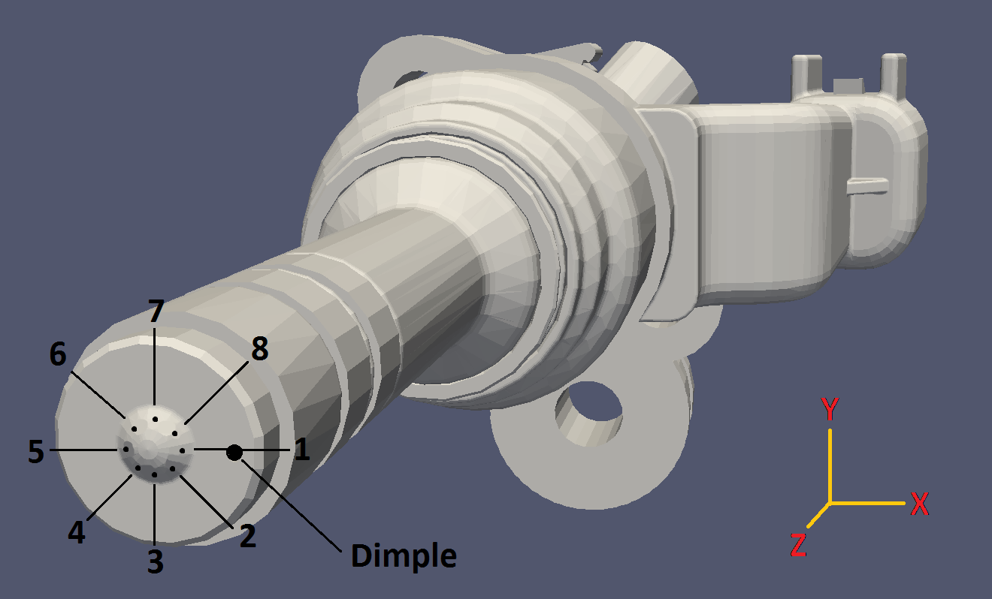
Fig. 1. Hole numbering and coordinate system convention of Spray G
Note that the tip protrudes past the hole exit, meaning that the plumes begin at negative z values. Conventions for describing the drill angle and derived plume geometry are given below. Another coordinate system z´, colinear with the hole drill angle and beginning at the exit of the inner hole (z´ = 0), is introduced for use with internal flow simulations and experiments.
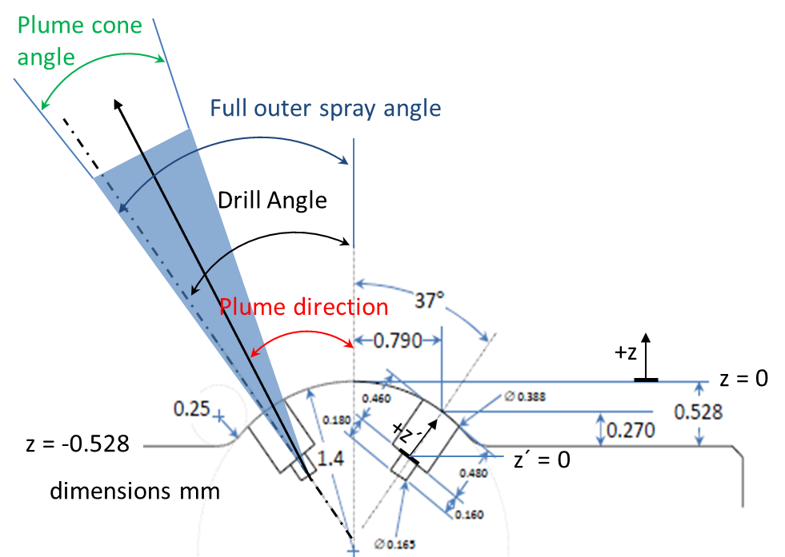
Fig. 2. Specified Spray G dimensions and nomenclature
Hole and nozzle internal geometry should use the nomenclature denoted in Fig. 3. If possible, report these data for each hole separately.
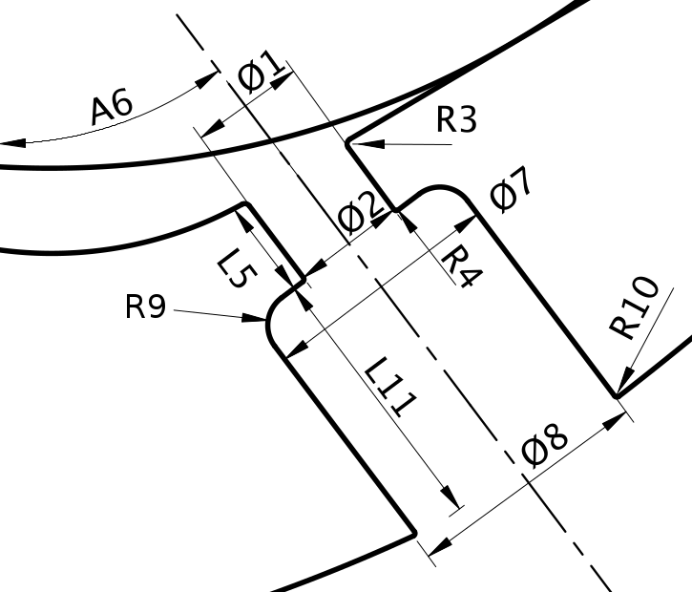
Fig. 3. Key spray G hole dimensions. Adapted from Strek et al. (SAE paper 2016-01-0858).
Detailed 3D geometry surface, CAD, and mesh files are available at https://ecn.sandia.gov/gasoline-spray-combustion/computational-method/mesh-and-geometry/ . While legacy simulations may have been performed using specified (Gen 1) or measured (Gen 2 or Gen 3) geometry, the preferred geometry for ECN8 simulations is the Generation 3.2 geometry. The Generation 3.2 geometry, generated for injector #28, incorporates the most detailed measurements available (performed by Argonne using x-ray computed tomography) but also removes artifacts and includes upstream geometry not available in the measurements.

Rate of injection
Measured rate of injection for use in simulations is given at https://ecn.sandia.gov/gasoline-spray-combustion/target-condition/primary-spray-g-datasets/. PLEASE NOTE THIS IS A NEW RATE OF INJECTION, updated after ECN5. RERUN OLD SIMULATIONS USING THIS NEW RATE OF INJECTION.

Needle movement
X-ray phase contrast measurements of needle lift and wobble are provided for Injector #28 at conditions close to G1, G2, and G3, with unheated ambient conditions. These data are available at https://anl.box.com/v/XRaySpray

Temperature
Fuel temperature, nozzle temperature, and gas temperature are as specified at the start of injection. For engine simulations, state assumptions for representative gas temperature and pressure (or density). Specifying non-adiabatic wall conditions is encouraged.

Initial dissolved non-condensable gas content
Simulations will be performed with no non-condensable gas addition.

Initial ambient gas motion
For engine simulations, the characteristics of air flow at the simulation start are to be given in terms of tumble ratio and/or swirl ratio.

Submission of experimental and modeling results
Using the defined coordinate system, all experiments and simulations will provide data relative to the start of injection. Start of injection is defined as the time of emergence of first liquid out of the counterbore section of the hole. Needle movement occurs earlier.
Experimental submissions from past workshops are listed in Appendix A. Expectations for experimental and modeling submissions for ECN8 are listed in Appendix B. We encourage archiving experimental submissions with documentation for each variable, as described at https://ecn.sandia.gov/gasoline-spray-combustion/experimental-data-search/ .
Submissions will include several processed indicators of spray penetration and growth as a function of time, as well as detailed 2D cut-plane or projection data at specific locations and timings.

Data format
Raw numeric data is required. Simple time-resolved may be returned in delimited format. 2D data may be binary, provided a reader program or script is provided. One option is to use standard image format (.png, or .tif) without truncating or changing the range of the data in time. By providing the pixel dimensions, and the minimum and maximum quantities, the image data is easily converted to numeric quantities, as shown in Appendix 3.
For a time-resolved, global quantity, please use the naming format QuantityvsTime.txt, e.g., “ROI_hole1vsTIME.txt”. For a 2D binary data please use “QuantityLocationTime.png”, e.g., LVFz2mm0600.png for z = 2 mm data at 0.600 ms after start of injection.

Global and Time-Resolved Spray Indicators
These are quantities describing the overall spray behavior, resolved in time.

Vapor penetration:

Experimental
Schlieren or other diagnostics sensitive to fuel vapor are utilized in either the primary or secondary orientation. Penetration is defined as the maximum axial penetration of ANY plume, as described in https://ecn.sandia.gov/gasoline-spray-combustion/experimental-diagnostics/gasoline-jet-penetration/ .

Modeling
Defined as the farthest axial distance where mixture fraction is less than 0.001.

Liquid-phase penetration:
To assess the vaporization characteristics of the spray, we define a threshold for axial (or radial) liquid penetration. Past work has shown inconsistency when using a Mie-scatter diagnostic and other difficulties if using a liquid-volume fraction criteria, as explained by the ECN5.9 slides and recording given by Pickett, accessible at https://ecn.sandia.gov/gasoline-spray-combustion/experimental-diagnostics/liquid-penetration-length/ . The parameter for comparison will be the “projected liquid-volume” defined as
$\int_{-y_{∞}}^{y_{∞}}{LVF∙dy }$ (1)
where LVF is the local liquid volume fraction (i.e. units of mm³ liquid / mm²) and y is the cross-stream direction (x could be exchanged for y for Spray G if appropriate for the experiment).

Experimental method to derive projected liquid volume
Laser extinction or diffused backlit imaging (DBI) with sufficient radiance and collection angles to eliminate beam-steering are required to perform these experiments, as detailed in the above links and presentations. Past datasets which show beam-steering may be analyzed and offset to account for beam-steering, while documenting all assumptions. Note that G2 and G3 conditions may exhibit little beam-steering artifacts because of the lower ambient density and cooler ambient temperature, making it possible to analyze the data quantitatively. Extinction measurement provide the optical thickness τ of liquid objects along the beam path, where the transmitted intensity I normalized by the baseline light intensity I₀ is related to τ by
$I/{I_{0}}= e^{-τ}$ (2)
and the optical thickness is related to extinction along the path due to liquid with
$τ= \int_{-y_{∞}}^{y_{∞}}{C_{ext }^{*}}\frac{LVF}{π{d^{3}}/6}dy$ (3)
where d is droplet diameter and $C_{ext }^{*}$ is the extinction cross-section from Mie-theory, depending upon droplet size, wavelength, and collection angle (the * superscript designates collection with a finite collection angle, rather than complete extinction). If one assumes a monodisperse droplet size distribution, Equation 3 becomes
$τ\frac{π{d^{3}}/6}{C_{ext }^{*}}= \int_{-y_{∞}}^{y_{∞}}{LVF}∙dy$ , (3)
Allowing the measured optical thickness and estimates for droplet optical properties. For the sake of consistency, we will assume a droplet size of 7 μm, based upon SMD measurements performed by Scott Parrish (GM) at the periphery of the plume (see https://ecn.sandia.gov/gasoline-spray-combustion/target-condition/primary-spray-g-datasets/) and a refractive index of 1.391 for iso-octane. Under these assumptions, Mie-scatter theory (recommend use of http://www.philiplaven.com/mieplot.htm) with a detector collection angle of 225 mrad at 633 nm yields $C_{ext }^{*}=44.6∙{10}^{-6} {mm}^{2}$ . The left-hand side of Equation 3 may therefore be evaluated (for this example) to estimate the projected liquid volume.

Liquid-extinction length
Because of the need to explore sensitivities in models and experiments, two different thresholds are required:
.
$$\int_{-y_{∞}}^{y_{∞}}{LVF∙dy=0.2∙{10}^{-3} \frac{mm^{3} liquid}{{mm}^{2}} AND 2.0∙{10}^{-3} \frac{mm^{3} liquid}{{mm}^{2}}}$$
The maximum axial position (of any plume) with liquid-volume projection less than these “low” and “high” thresholds will be referred to as “liquid-extinction” length.

Liquid-extinction width
At an axial position of z = 15 mm, the radial width at these two thresholds is defined as the “liquid-extinction” width.
Both the liquid-extinction width and liquid-extinction length will be returned with respect to time. In the next section, 2D datasets for liquid-volume projection will also be requested for further analysis at particular time steps.

Spatial- (and time-) resolved variables
Requested 2D binary data (see Data Format above) are to be provided on different cut planes (Fig. 4). Provide data from 0.1 – 2 ms (or max) in 0.1 ms time-steps.
- Axial (x-y) cut planes: z = 1, 2, 10, 15 mm
- Axial cut plane normal to the drill angle (z’, Fig. 2): z´ = -0.1, 0, 0.1, 1.0 mm
- The central x-z cut plane (z = -2 to 40 mm) in primary position
- The “secondary” x’-z cut plane (z = -2 to 40 mm, rotated about z by 22.5 degrees)

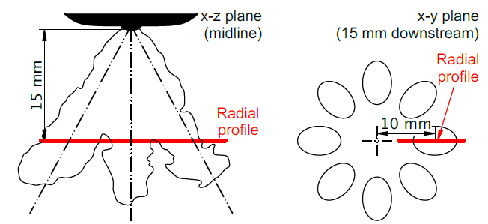

Fig. 4. Illustration of 2D cut planes for data analysis (see Duke et al. Experimental Thermal and Fluid Science 88:608-621, 2017).
The 2D binary data requested include:
    - 3 component gas and liquid velocities (m/s)
    - total liquid and vapor fuel mixture fraction (mass of liquid fuel and vapor fuel/mass of all mixture)
    - mass liquid fuel / volume (not liquid fuel density, kg fuel / m³)
    - liquid volume fraction (volume liquid / volume)
    - fuel vapor volume fraction (volume fuel vapor / volume)
    - non-condensible gas (nitrogen) volume fraction (volume nitrogen / volume)
    - total mixture density (fuel and all other gases / volume)
    - projected liquid volume (x-z plane, integrated in y direction, mm³ liquid /mm²)
    - temperature (K)
    - sauter mean diameter droplet size (μm)

Description of the simulation
Rather than a prose submission, descriptions will be submitted for all simulations using the following numbered items:
- The name of the phase-change model and a seminal reference where interested readers can learn more about the details. A sentence or two about the basic phenomena captured by this model is also expected.
- An explanation of how fluid properties were calculated or tabulated. This may be a reference to a database or an equation of state.
- Does the internal simulation couple to an external spray simulation? If so, how?
- What turbulence closure is used?
- What is the initial gas and liquid velocity and turbulence distribution at the time of injection?
- What form of the energy equation is used, if any. How was the wall treatment determined? Were walls treated as adiabatic, isothermal, or other?
- Were any special phenomena considered? Examples are compressibility, dissolved gas, nucleation.
- Did you specify ROI, or another variable such as needle position or injection pressure?
- What needle lift was used, fixed or variable? If a fixed needle lift was used, what was the value? Also, was wobble included?
- For moving needle cases, how was the beginning and end of injection treated? Were baffles removed or inserted to stop flow? Does the algorithm automatically seal the injector needle to the seat or must some model be employed? If a static need was used, leave this blank.
- What geometry was used? Please provide as much information about the provenance of the geometry as possible. See https://ecn.sandia.gov/gasoline-spray-combustion/computational-method/mesh-and-geometry/ for generation 1, 2, and 3 geometries.
- What mesh paradigm was used? Please indicate the basic meshing strategy and the number of cells. If the number of cells varied during the simulation, please explain. For moving needle computations, explain how the mesh was morphed or topologically altered. The submission should include a saggital plane snapshot of the mesh at full needle lift. Avoid slices that cut through individual cells, but rather give a crinkle-cut slice if possible.
- What interface treatment was used? This should be several sentences. For example, it is not sufficient to say “VOF” but rather explain whether a geometric interface construction was used or some interfacial compression scheme was employed with flux limiting. If a diffuse interface treatment was used, be sure to provide a reference that describes the governing equations.
- Provide a table of boundary conditions that was used for each equation.

Specific requests for Topics 7 & 8 internal and near-nozzle, evaporating spray
Due to the prioritization on the G2 condition, internal and near-nozzle studies under evaporating conditions will be analyzed in conjunction with Topic 8.
Prioritization of conditions to be examined are G2, G3, G3HT, G1-cold, G1. At all conditions, the effectiveness and introduction of variability should be investigated for multiple-injection strategies. Specifically for G2 conditions, efforts should be made to investigate behavior of plume interaction and collapse and the role of multi-component fuels in this behavior. Furthermore, internal flow behavior downstream of the check-ball under G2 conditions should be examined, particularly with multi-component fuels.

Internal flow simulations
Note that the time datum for internal injection calculations needs to be adjusted to match the defined start of injection. Time 0 is the time of the first passage of liquid out of the hole counterbore for any one of the eight holes. Internal simulations submissions should include the following:
- Predicted mass rate of injection in g/s versus time in ms. This should be submitted as a plain text ASCII file with time as the first column and ROI as the second.
- Predicted mass rate of injection of each hole in g/s versus time in ms. ROI should be measured at the small-hole exit. This should be submitted as a plain text ASCII file with time as the first column and ROI as the second. This should be a nine column table where the first column is time in ms and the subsequent eight columns correspond to the mass flow of each hole.
- Provide the liquid fuel ROI, fuel-vapor ROI and non-condensable gas ROI similar to the total fuel ROI in item #2.
- Time average 2D data requested above for the quasi-steady state, i.e., the period of near-maximum needle lift from 0.4 to 0.6 ms ASOI. Use the naming recommended above, i.e. “QuantityLocationTime.png”, e.g., LVFz2mm0400-0600.png for z = 2 mm data at 0.600 ms after start of injection.

Evaporative spray simulations
- Provide information about:
  - Initial spray angle and how it was selected
  - $C_{a}$ and $C_{d}$ values used in the simulation and how they were selected

Specific requests for topic 9 “Spray G in engines”

Operational and boundary conditions
- Combustion chamber layout: due to the characteristics of Spray G injector, preferred configuration would be spray guided with central injector location.
- To avoid complex interactions between the flow field from the intake ducts and the piston shape, a flat piston configuration is recommended (but not required).
- Intake pressure (or even compression ratio) and injection timing should be adjusted, if possible, to match as close as possible the target 3conditions defined above at start of injection (SOI).
- No specific engine speed is recommended. Low engine speeds (<1000 rpm) can be considered to achieve a more direct comparison with quiescent chambers while the impact of the flow on spray propagation is expected to increase with engine speed.
- Spray G1 and G3 are the preferred operational conditions, since in-cylinder experimental data on flow and spray are already available. For these operational conditions, further measurements are recommended with a focus on the development of the individual spray plume angles and the mixing field (air/fuel ratio). G2 (flashboiling) and G-M1 (multiple injection) are recommended as further interesting operating points.
- It is recommended to start the investigations of the spray within the motored engine to reduce the complexity as much as possible before considering fired engine operation.
- For simulation activities, researchers are encouraged to perform complete simulations including both intake and compression strokes, so that 3-dimensional intake flow features are reproduced. To do so, the following information should be made available from experimental activities:
  - Air mass flow
  - Measured in-cylinder pressure and intake pressure
  - Complete intake and in-cylinder geometry
  - Intake valve timing and lift profiles

Open questions and quantities of interest
- The aim of topic 9 is to assess how well models predict spray evolution under real engine conditions. In this context the spray plume cone angle is an important characteristic. Even though the trend of change due to ambient conditions is mostly captured well the actual value is often considerably under predicted. Therefore, the questions of interest are:
  - What is the influence of the underlying turbulent flow field on the spray plume cone angle?
  - How is the spray plume cone angle affected by the continuous changing in-cylinder conditions?
To investigate these open questions the experiments/simulations should be as consistent as possible with the available investigations which already have been performed within pressure vessels. This gives the opportunity to include experimental as well as numerical data from vessels into the analysis. All experiments and simulations devoted to this topic are appreciated. These can include specially designed experiments for the validation of numerical simulations as well as experiments/simulations focusing on parameter variations (for example engine speed).
- The focus of the comparisons will be on the spray evolution and morphology. Therefore, following quantities are of interest either from simulations or experiments:
  - Spray plume cone angle
  - Spray angle
  - Axial liquid penetration
  - Visualizations of the spray morphology at different times during the injection phase
  - Regions of wall wetting (if it occurs)
  - In-cylinder flow field (gas) before and during injection (mean, turbulent kinetic energy)
  - Temperature
  - In-cylinder pressure/temperature trace

Specific requests for topic 10 Spray G combustion

Objective:
Experimental contributions:
Experimental measurements related to the Spray G wall impact and combustion. No strict definition of boundary conditions is required. Main target quantities:
- Liquid film thickness
- Spray-Wall heat flux
- Soot formation
- Etc.
Also, diagnostic development related to the previous measurements (even if not related to spray G case). Ex: LIF for liquid film thickness measurement, heat flux, wall temperature
Modeling contributions:
Results from numerical simulations related to the reference case presented in ECN 7 and in the reference (Shway et al, Quantitative UV-absorption imaging of liquid fuel films and their evaporation, ICLASS, 2021). For inert and Reacting case. No specific data format is required, and the accepted data can be either for a direct comparison to the experiment or complementary data (e.g. simulation of wall temperature evolution during the impingement).
Description of the reference case

Experimental Layout:

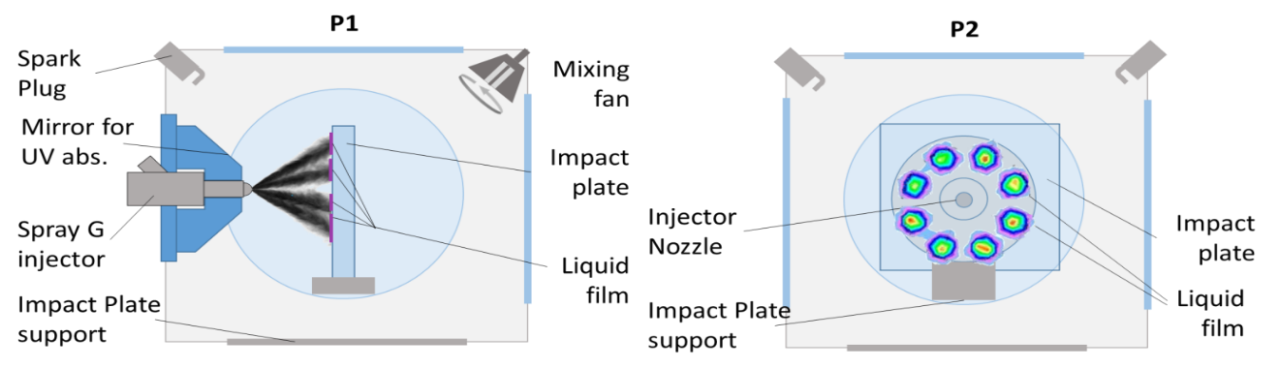

Test conditions:
Main boundary conditions
Fuel: | 30% toluene + 70 % iso-octane
Injector: | Spray G AV67 – 022
Wall distance: | 30 mm
Inj. pressure: | 200 bar
Tgas / Plate: | 100°C
Pgas: | 1 bar
T fuel: | 90 °C
t inj: | 0.780 µs è1.5ms (hydraulic)
Inert case: | O₂ 0% (only N₂)
Reacting case | O2 15% residual (gas + fuel)
Orifice ref: | 3
Experimental procedure:
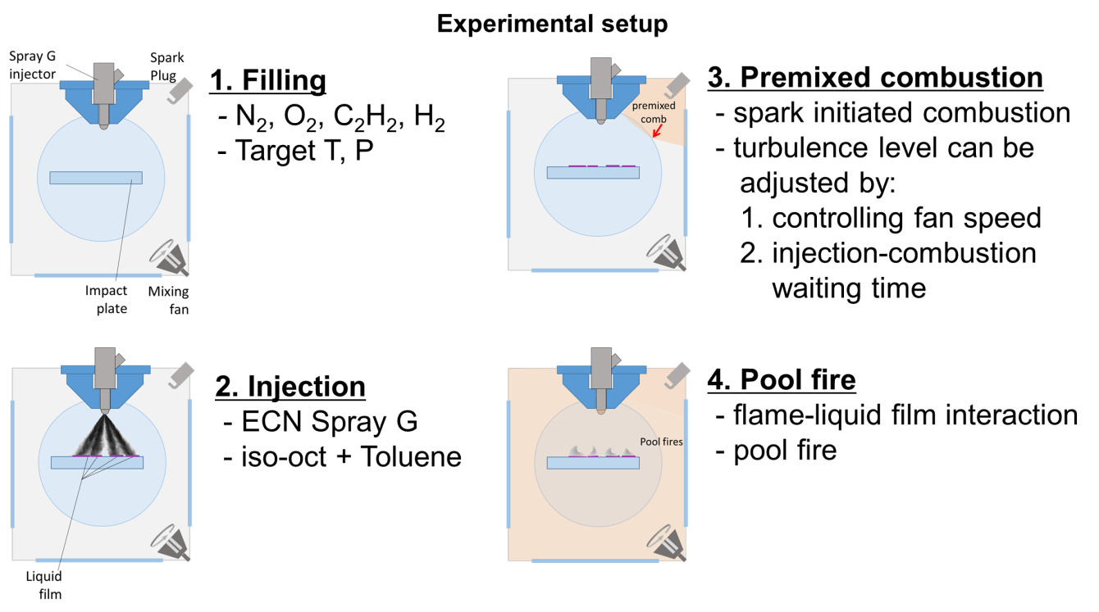
1/ the vessel is filled with a homogeneous mixture of N₂, O₂, C₂H₂, and H₂
2/ fuel is injected on the impact wall.
3 and 4/ a spark plug initiates a premixed laminar flame. When the flame reaches the spray impact area, the liquid film starts burning in pool fire mode.

Inert case experiments include only steps 1 and 2. Reacting case experiments follows steps from 1 to 4 including liquid film interaction with premixed flame.

Key quantities (time resolved):

liquid film thickness: Liquid fil thickness maps, and time evolution of total mass and total surface are available for the reference case (Shway et al, ICLASS 2021)

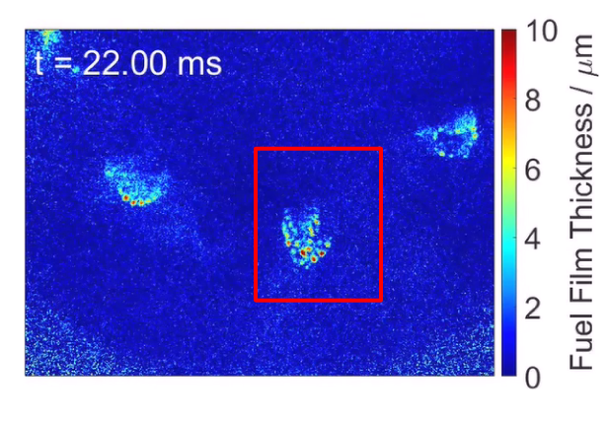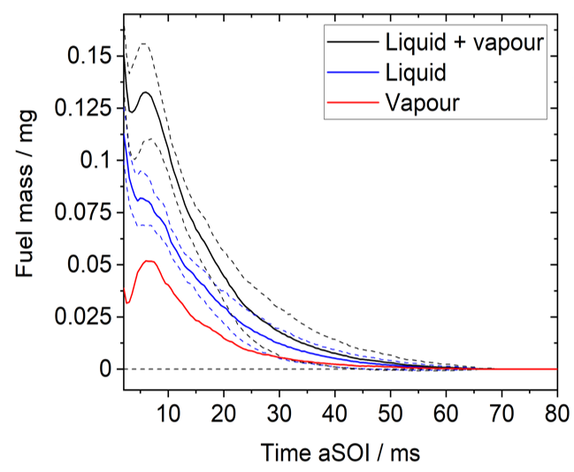

soot extinction (soot mass/ formation timing / distribution) are available for reacting case simultaneously to liquid film measurements

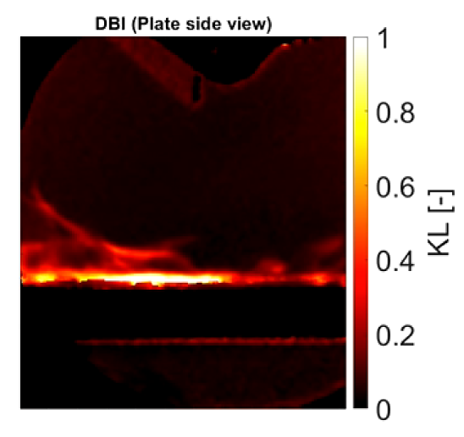

Open questions
The aim of topic 10 is to start a collaborative task on spray impact and combustion phenomenon. Liquid film and soot formation are the main unknown to be explored, but all other quantities related to the phenomenon will be of interest.
All ECN experimental and modeling contributors starting spray G-wall impact activities are encouraged to participate to the discussion looking for complementarity of the measurements and trying to converge as much as possible in the boundary conditions.

Appendix 1: AVAILABLE Experimental Data
Available data is found at https://ecn.sandia.gov/gasoline-spray-combustion/target-condition/primary-spray-g-datasets/ . Details have been presented at ECN workshops and monthly webex meetings. You may search past presentations at https://ecn.sandia.gov/ecn-workshop/search-presentations/ .
A summary of available data, not all posted to the ECN website, is shown below (it can be updated at any time).

Liquid-extinction Penetration, Vapor Penetration, and Spray Width.
Institution | Source | Pos | Condition | Reference
Melbourne | DBI and MIE  Schlieren | 1 | G1, G2, G3
Sandia | DBI and Mie  Schlieren | 1 & 2 | G1, G4, G5, G6, G7, G-M1 | ECN website  SAE 2015-01-1894
CMT | DBI  Schlieren | 1 | G1, G2, G3, G4, G5, G6, G7, G-M1  parametric variations:  1 to 9 kg/m³, 300 to 800K, 680-1200us, 100-200 bar (120 conditions) | Payri et al., Applied Therm. Eng. 2016  ECN5
Ist. Motori | MIE  Schlieren | 1 | G1, G2 (cold), G3 (cold)  Cold = Ambient temp.
IFPEn | MIE  Schlieren | 1 | G1, G7 | SAE 2015-01-1902
GM | MIE  Schlieren | 1 | G1, G-M1 | SAE 2015-01-1894
Illinois | DBI  Schlieren | 1 | G1, G2, G3 | ECN 5.7
1: primary orientation (0 deg), 2: secondary orientation (22.5 deg) Check orientation

Velocity, density, concentration, mixture fraction.
Ins | Data | Source | Condition | Notes
Argonne | Fuel density / volume, spray surface area | x-ray radiography, USAXS | G1-cold, G2, G3 | z = 1 & 2 mm, 2D projections
GM | Liquid velocity and SMD | PDI  Phase Doppler Interferometry | Spray G | Radial and transverse at 15mm from nozzle tip.
IFPen | Fuel mass concentration  Temperature fields | p-DFB LIF  two color LIF | Spray G  3.5 kg/m3 673K  6kg/m3 700K 9kg/m3 800K | Iso-octane + 0.03% vol. DFB  Primary orientation
Sandia | Gas velocity fields between plumes 13 – 20 mm downstream | PIV | G1, G4, G7, G-M1  Longer injections | Secondary orientation

Spray G in engines
Ins | Data | Source | Condition | Notes
Darmstadt | Gas velocity fields,  side-view Mie (penetration, width) | PIV  MIE | G1, G3 | Iso-octane  800/1500 rpm
Duisburg | Gas velocity fields,  side-view Mie (penetration, width) | PIV  MIE+DBI | G1 | Iso-octane  1200 rpm
Michigan | Bottom-view Mie spray morphology (width) | MIE | G2, G3 | Iso-octane  300/1000/2000 rpm  SAE 2018-01-0305

Appendix 2: Gasoline spray committee -- participants for ECN8

Inst | Contact | Type | Topic | Notes
Argonne | Chris Powell  Brandon Sforzo | Experiment | 7  8 | Needle lift, geometry, fuel density  G2-cold radiography
GM | Scott Parrish | Experiment | 7 | Microscopy inside counterbore
Sandia | Lyle Pickett | Experiment | 7  8 | Microscopy of spray, geometry  Velocity, liquid volume
ORNL | Martin Wissink | Experiment | 7 | Needle motion, neutron imaging
Argonne | Lorenzo Nocivelli  Hengjie Guo  Muhsin Ameen | Simulation | 7  8 | VOF at G1-cold  ELSA, one-way, Lagrangian  Nek5000
Chalmers | Michael Oevermann | Simulation | 7 | G2 presented at ECN5.8
Siemens | Samir Muzaferija | Simulation | 7
UMass/GM | David Schmidt | Simulation | 7
CMT | Daniel Vaquerizo  Joaquin de la Morena | Experiment | 8  9
Illinois | Wayne Chang | Experiment | 8 | G2
Ist Motori | A. Montanaro | Experiment | 8
Melbourne | Joshua Lacey | Experiment | 8 | G2
GM | Scott Parrish | Experiment | 8 | G1, G-M1
IFPEN | Gilles Bruneaux | Experiment | 8 | G1
Chalmers | Petter Dahlander | Experiment | 8 | G2, PDI plans
SJTU | Sean Li | Experiment | 8 | G2, PDI
PoliMi | Davide Paredi | Simulation | 8  9 | G1, G3
UW | Randy Hessel | Simulation | 8
KAUST-UW-Aramco | Hongjiang Li | Simulation | 8
Darmstadt | Christian Hasse | Simulation | 8  9 | G1, G3
Illinois | Chia-Fon Li | Simulation | 8
Michigan | Margaret Wooldridge | Experiment | 9 | G2, G3
Duisburg- Essen | Sebastian Kaiser | Experiment | 9 | G1
Darmstadt | Benjamin Boehm | Experiment | 9 | G1, G3

Appendix 3: Example to convert binary image data to floating-point data
This example Matlab script shows how to read an 8 bit grayscale image on the current ECN website, converting it to floating point liquid volume fraction data with inputs for image range. Image scale is also given, providing actual spatial dimensions.
%example for accepting grayscale .png file (binary) and using for analysis
%(1) download "data" .png file for Spray A liquid volume fraction at
%https://ecn.sandia.gov/wp-content/uploads/2015/06/s675x0.1tox3z0a.png
im = imread('s675x0.1tox3z0a.png');
%im is grayscale 8 bit with 301 x 1550 pixels
%(2) get maximum and minimum for image range:
% given at https://ecn.sandia.gov/wp-content/uploads/2015/06/s675x0.1tox3z0ag.png
imMin = 0; imMax = 1.04; nPixy = 301; nPixx = 1550;
%(3) get scale of pixels, and reference:
%given at https://ecn.sandia.gov/wp-content/uploads/2015/06/s675x0.1y_column.csv
dPix = 0.002; % 2 um per pixel
pixNoz = 151; % pixel 151 is center of nozzle
y = ([nPixy:-1:1]-pixNoz).*dPix; % given vector for y axis
x = 0.1+ ([1:1:nPixx]-1).*dPix; % given vector for x axis
LVF = imMin + single(im)./256*(imMax-imMin);
%image data now converted to quantitative liquid volume fraction

%% show data in Matlab "jet" colormap
figure(4), imshow(LVF,[imMin imMax]);
colormap(gca,jet);

%% get cool-to-warm colormap at http://www.kennethmoreland.com/color-advice/
% dowload byte map 256
m = dlmread('smooth-cool-warm-table-byte-0256.csv',',',1,0);
coolWarmMap = m(:,2:4)./256;
% show data in cool-to-warm colormap
figure(5), imshow(LVF,[imMin imMax]); %show cool-to-warm image
colormap(gca,coolWarmMap);

%% most importantly, use data quantitatively
% examine LVF profile at certain axial distance
axd = 1; %data at x = 1 mm
a = find(x>axd,1,'first');
figure(6), plot(y,LVF(:,a));
ylabel('Liquid volume fraction [au]');
xlabel('Radial position [mm]');
text(-0.2,0.8,'x = 1.0 mm','fontsize',16);

